SECTION III

Reunion Tales

Oh, the Pride and the Joy!
From Issue 11 of the FPA Newsletter
Duncan Stirling, Ronnie King, Colin Crichton and Donald McKenzie are stalwart representatives of the 1949 entry and got together recently. This is part of an article about their meeting. The rest of the article will appear in the May (1997) Issue. It may evoke memories among their contemporaries.
Cast your mind back to the early sixties when we were all starting out on a career or studying towards gaining professional qualifications. Colin was right at the fore-front of new engineering practice, conducting Time and Motion Studies on Production Line assembly. Duncan was capitalising on his artistic talent, studying architecture in Dundee, having embarked on his first of many commissions - a new pavilion and changing rooms for Cupar Hearts FC. Donald had returned from a spell tea-planting in India and was furthering his agricultural experience working at Rumgally Farm prior to a career with the Potato Marketing Board. Ron had managed to pass another Civil Service Exam and was a recently Commissioned Officer of Customs and Excise with a more than passing interest in Distilleries, Breweries and Port activities in the East of Scotland. Despite these disparate career aspirations with the resultant travels away from home-base, the friendship arising from our attending Bell Baxter circa 1950 to 1955 was a continuing bond.
More to the point, at the time, we each had an interest in an out-of- the-ordinary motor car which required pooling of tools and experience to keep on the road. While they could be troublesome, time-consuming and even possibly unreliable on occasions, they really were a Pride and Joy for the majority of the time they were in our possession.

WHAT ABOUT A REUNION?
When Donald first mooted the idea of the reunion, it seemed that, forty years on, our remaining shared interest could be motoring. Colin has a stable of vintage vehicles including a rare Triumph TR2 which he has restored to factory-new condition. Ron has a modern (1980) MGB Roadster as a hobby car and Donald enjoys "pokey" products of a Far Eastern persuasion which left Duncan, and we solved that by settling on a day out at the Hill Climb at Doune Motor Museum which is not too far from his home in Dollar.
Sunday the 23rd June was the date set and Donald arranged for us to meet and have lunch at the Lion and Unicorn Inn at Thornhill, Colin coming from Skelmorlie over the Erskine Bridge, Donald driving down from Aberdeen and meeting up with Duncan at Dollar and Ron coming across country, over the Campsie Hills from Glasgow. Colin was accompanied by his wife Kay (also a Bell Baxter-ite nee Grant and originally from Tayport) and Duncan by his older brother Mike who is a Consultant Civil Engineer now resident in Brighton. He was up for a class reunion! It was amazing how quickly the intervening years sloughed off and the reminiscences started to flow. It was with some regret that we dragged ourselves away from our table for what would be the main event of the day - The Doune Hill Climb. As we got ourselves organised in the Inn car-park, it appeared that the fame of the Sweet trolley had spread as we were just in time to witness a swarm of bees appearing beside the roof of the Inn and disappearing down the chimney! This was followed very quickly by the appearance of the Landlord exiting fast. We did not hang about to await developments and made off at some speed for Doune!

Wow! That's Too Quick For Me!
The weather was warm and sunny which made the Doune Estate and the surrounding scenery an absolute picture of bucolic bliss. For us, the roar and snarl of racing car exhausts added a welcome dimension to the scene.
Vacant Place?
We specially remembered two aviators, Glen Stewart and Harry Sime who both met untimely deaths - Glen at the end of a long RAF career flying with Coastal Command and latterly as Captain with BA on their long- haul 747s and Harry, at the beginning of his RAF career as a navigator when the plane he was crewing had to make a forced landing in Holland. The pilot made valiant efforts to avoid a farm house and village school and thereby saved a lot of civilian lives, but all the crew perished. Harry's widow, June, and daughter Karen, along with Evelyn, his sister, visited the crash site in 1995, some thirty-five years on, at the request of the local villagers who wished to honour the valour of the crew who had sacrificed themselves in saving the village and its school children, inviting the relatives and RAF personnel to a civic ceremony and the unveiling of a plaque. A moving occasion which served to clear some unanswered questions and to give Karen an idea of the esteem in which her father was held.
Thank You(s)
Thanks to Donald for thinking of the reunion and organising the day. Thanks to David King and Lang Bros, for providing the prizes for the CDDR competition.
And thanks to all for turning up - let's find an excuse to do it again!

The last issue had an account of the re-union of four "young" men in June 1996. The description of their meeting was linked to reminiscences of the early sixties when they were savouring the delights of car ownership, as they embarked on their careers. It seemed that their reminiscences might evoke happy memories in other "young" men - and women!
Ronald King wrote, following his re-union with Duncan Stirling, Colin Crichton and Donald McKenzie:-
At the time, we each had an interest in an out-of-the-ordinary motor car which required pooling of tools and experience to keep on the road. While they could be troublesome, time-consuming and even possibly unreliable on occasions, they really were a Pride and Joy for the majority of the time they were in our possession.
Colin's Frog-Eye Sprite was the most elegant of the vehicles and was kept in pristine condition. It was usually redolent of GUNK engine cleaner and Wax Polish - it was never to be seen dirty, but then he had an A35 Van for daily use!
Duncan's Austin 12/4 Doctor's Coupe of 1930's Vintage had the most character, sitting high off the ground with two leather arm-chair seats for the driver and passenger and two occasional tip-up seats which faced each other, to the rear. A notable achievement was Duncan's conducting the car to the top of the Kinnoul Hill in Perth. The musty smell of the leather interior was definitely one to savour - it never went away.
Donald had an MG model TC circa 1949 which was an open-top roadster in a rather dashing red. It had a crab-like forward movement due to an encounter with an errant vehicle emerging from a side road, resulting in a twisted chassis. This modification allowed the car to self-steer round left-hand bends, but right-handers needed premeditation and strong arms.
Ron also had an MG TC, dated 1947 and in a rather tacky hand painted red. The paint had been applied in a fit of optimism while accounting for the product of Edradour distillery and arose from the local hardware store having a surplus of red VALSPAR - the Pitlochry housewives departing from their usual practice of painting their front doorsteps that year. A rather splendid pair of rear tyres was also acquired at a bargain price as they had been ordered for the local hearse but it, like its occupants, had expired and these would not fit the new conveyance.
"The Cresta Run" involved wintry early morning journeys from Cupar over the Garlie Bank to Cameron Bridge Distillery. The snow by the wayside was higher than the car while the slush on the road kept coming up through the gap between the pedals and the wooden floor. But that was all part of the fun of motoring in those days. No it wasn't - it was d d cold.
There were little tests we could apply to gauge the performance of our cars. Could you get more than sixty out of her along the Beet Factory straight? Did you have to change down to third (or even second) to climb the Guardbridge Brae? Was all that blue smoke really coming from my exhaust? Let's take the head off and give it a decoke! What about the crankshaft bearings?
None of these cars could be replaced for less than £15,000 today, but, at the time, other commitments, or lack of funds, took priority and they were allowed to go at bargain prices. Hopefully someone else got as much fun, practical experience and eccentric motoring as we did.

Reunion of some of the 1950 entry
This account (and the photographs which appear) came from Harry Smith, who lives in Pittenweem.
The school centenary celebrations in 1989 brought together a few of us who entered 1A1 in 1950. We felt it would be a good idea to arrange a class get-together but for one reason or another the matter wasn't pursued until the spring of this year (1997). Since the centenary, sadly, Tom Lamb and Beth Bowden have passed away - Beth after many years of ill health.
Contact with those listed in the Bell Baxter Chronicle brought an encouraging response, so Ian Donaldson, Jim Morton and I decided to go ahead. We felt the venue ought to be in Cupar, thus ruling out several potentially suitable hotels situated in the school catchment area. The demise of the Royal Hotel, a number of years ago, made the Howe of Fife RFC clubrooms an obvious choice, particularly since Ian is a member and was able to do an excellent liaison job with the stewardess.
The first year photo told me who should be invited, but there were others who must have been absent that day - Bill Marshall, Isabel Robertson, Alison Yule, Ena Cumming. The Chronicle was an invaluable source of addresses and others were known to those we had contacted. Nevertheless, a number seemed to have disappeared without trace. The last resort therefore was a letter to the Dundee Courier which as it turned out brought an excellent response.
So, on the day, the gathering comprised Ailsa Kelman, Muriel Bell, Douglas Blyth, Tom Blyth, Arthur and Dorothy Dall (formerly Dorothy Anderson from the year below ours), Ian Donaldson, Bill Marshall and his partner, Ann Bridges (widow of FP Robert Bridges), Jim and Shirley Morton and Harry and Fay Smith. We were delighted that Isabel Russell was able to look in briefly on her way to her niece's wedding.
The re-union was voted a great success. Not only was there much reminiscing, but in the intervening 40 years there was quite a bit of news to catch up on. It was indeed a gathering of old friends, no doubt indicating the creation of a strong bond in our formative years. By the time we dispersed around 5 o'clock it was generally agreed we should meet again preferably some time before the millennium. It has also been rumoured that a year re-union arranged by the FP Association will be held next year. If so, you will be advised well beforehand. In the meantime, we intend to meet twice a year on the last Friday of March and September for a totally informal light lunch at Kind Kyttocks Kitchen, Crosswynd, Falkland (where the plot was hatched for our get-together this summer!) so why not try to join us?
Harry Smith

This contribution from Frances Dalton appeared in Issue 13 of the FPA Newsletter.

After Many Days
On Saturday 12th April 1997, eleven of those of us who had gathered together for the Class of ‘46 Reunion last summer met for lunch at the Royal British Hotel, Princes Street, Edinburgh.
Actually the motivation of those of us who decided to have the meeting and who all, apparently, enjoyed it, has to be interesting: such an event does perform the function of reminding us seriously of the passage of time … which many can find quite scary! On the other hand, it can be remarkable to discover how much vitality can be around in people of one's own age group, how much humour, how much sense of fun. And although obviously we have all moved on and there have been many changes - marriages, careers, locations, families - people still seem refreshingly to possess those qualities which may have enabled us to be friends in the past, and to remain friends still. I can't speak for the others, of course, but I myself have found this a totally rewarding part of the experience.
Indeed the gathering seems to have been much more than a convivial conversation club, although of course there was much of that!
I was allowed two paragraphs on this and as usual I find I have too much to say (or write). But if others are willing, keen, nay brave enough to attend such an occasion, I think they might be pleasantly surprised: I heard stuff about goings-on in and around Cupar and school of which I seem to have been totally unaware whilst there! Was I going around in a dream? Or do we all have selective recall as well as selective attention? Then there were the raconteurs, the round the world adventurers … and those capable of listening when one had one's own tale to tell … and the affirmation of revived memories. Powerful stuff! My sincere thanks go to Alice, Ann, David, Ed, Helen, Hugh, Jean, Margaret, Roy and Sylvia for helping to make it a memorable occasion. And I'm sure we all hope John makes it next time and doesn't have Alice looking all over Waverley Station and Princes Street for him!
Frances M. Dalton (née Wilson)
20.6.97.

1948 Reunion
The 1948 Reunion was held on 6th June 1998 in the Eden House Hotel, Cupar. Over 60 former pupils attended including some of the committee. We were happy to have the company of Sandy Adamson, Kenneth Nicholl and the present Rector, Douglas Campbell. The day turned out to be the wettest ever, but this did not dampen the spirits of those who turned up at 11 am to see through their old school.
We all met in the staff room, and the sound of the chatter of voices of many people meeting for the first time since school days, had to be heard to be believed. How Mr. Campbell managed to quieten us seemed to be an impossible task, but quieten us he did by standing on a table and shouting that "we were the noisiest class he had ever heard". He went on to welcome us and gave a short speech informing us about the present day Bell Baxter and reminding us that we of former years were not forgotten He also said that Bell Baxter was such a special school that it left us with the "feelings" that brought us back here today.
We then wandered at will through the school, poking into the classrooms and remembering the teachers who had been in them.
One former pupil had a good look in one of the old desks of a former teacher to see if his mouthorgan confiscated fifty years ago was still there - but no luck! There were many stories and reminiscences bandied about as we wandered along the corridors. It was funny how everything looked so much smaller than we remembered it to be. This visit proved to be so successful that it was quite a task to hurry everyone along in time for lunch. Many grateful thanks again to Mr. Campbell for making this possible.
On to the hotel then for 12.30 pm. One or two who had not managed to the school were already there and we welcomed them. Class photos and letters from former pupils, unable to attend, sending their good wishes, were laid out on the table.
Alistair Dow gave a short welcoming speech and asked Sandy, who also started at Bell Baxter in 1949, to cut the cake. We then sat down to a spendid buffet lunch. Congratulations to the catering staff.
Many old friendships were rekindled and promises for future meetings were made. The years just slipped away as if they had never been. There was much laughter round the tables and one eminent surgeon was overheard to remark “I don't know why I'm enjoying myself so much because my idea of a good day out is not spending a Saturday with six grannies!” Everyone mixed so well and nobody was left on their own or felt unwelcome. The rain stopped in time for us to have our photograph taken outside.
About three weeks later we went to visit Miss Livingstone at her home in Cupar and Miss Robertson in a nursing home in Leven, delivering bouquets and the "good wishes" of the ‘Class of'48’. They were both fairly well and in good spirits and very pleased to see us.
In the days after we received many phone calls and letters of thanks and appreciation for such a wonderfully warm gathering. It made our hard work worth while.
Here's to 2008.

THOSE WHO ATTENDED THE REUNION

Sandy Adamson (qv) Mary Anderson Anne Angus Christine Arthur
Janet Blyth Scott Blyth Greta Borthwick Robin Brotherton
Gavin Cairns Isobel Cairns Douglas Campbell (Rector)
Dorothy Carrie Margaret Carswell Sylvia Chisholm David Crowe
Ella Currie Jean Don Anne Donaldson Alister Dow
Muriel Dymock May Ewan Nancy Fleming Ian Galloway
Mrs. Galloway George Gordon Sheila Gray John Hart
Nessie Henderson Bill Home James Howitt Hilary Lewis
Cecily Lumsden Tom Lumsden Sheila MacDonald Helen McKenzie
Clouston Mclntyre Ian MacLeod Tom McPherson Merilyn McRae
David Marshall John Matthews Margaret Mathieson Norman Meekison
Bill Meikle Pat Melville Gordon Muir Betty Neville
Kenneth Nicoll Nancy Pearson George Peggie Betty Pottie
Isobel Riddle Joan Shaw Peggy Shepherd Joan Shirras
Andrew Small Betty Smith Ann Steven Lorna Syme
Regina Wallace

Class of ’49 Reunion
The morning of the 26th June 1999 dawned bright and fair, with great promise of the day to come, and, as it turned out, we were not disappointed.
En route to Cupar, Betty Pottie duly collected the cake and delivered it to the Eden House Hotel, where she met Kate Westwood and Joan Russell, before speeding off to the old school to meet those gathered there.
An enjoyable hour was spent wandering round the old haunts punctuated by "Hurry up" from Betty, followed by one quip of: "It's easy seen what your job was".
Following this, everyone congregated at the hotel to be issued with name badges, in order to be recognised after 45 years!! It was amazing how many were recognisable once the name had been noted.
An excellent buffet lunch was served and enjoyed by all, after which Betty welcomed everyone and read replies from those who unfortunately could not attend.
Don MacKenzie then gave an amusing response on behalf of the FPs.
Kenny Nicoll was asked to cut the cake, as he had joined the staff of Bell Baxter in 1949, then he said a few words. His amusing reference to his being afraid of Doc Inglis caused some mirth and struck a few sympathetic chords in our hearts.
Having partaken of a splendid meal we moved to the garden to enjoy the glorious sunshine and have photographs taken.
All those who attended expressed great enjoyment of the day, having renewed old friendships, and a wish to repeat the gathering in the near future.
A few weeks after the reunion, Peggy McMahon arranged to meet up with Margaret Will, who was over for a visit from Australia (unfortunately she was unable to make the reunion) and Luisa Ferrari before she returned home to Colombia, and they all had a most enjoyable time catching up with all the news and no doubt reminiscing over the past years.
Very sadly, two of our numbers, Joan France (née Russell) and Peggy Matthew (née McMahon) passed away, Joan on the 28th July, only a month after this event, and Peggy in October.

Betty and Kate.

June 2000 Reunion
The 24th of June saw 170 people converging on the School at around 1130 am. There were the usual exclamations of astonishment as people who had not seen each other for - in some cases - 55 years met face to face and hoped secretly that they looked as young as the contemporary they were confronting! (That is the more tactful way to put it.) It took some effort and the tuning up of retired school teacher voices to attract the attention of everyone and bring them together to witness the presentation of the new clock. The School Rector Mr Douglas Campbell, the Depute Rector, Mrs Kath Russell, the Girl Captain, Alison Pearce, and the Boy Vice-Captain, Mark Allan, were present for the occasion. The Chairman of the FP Association, Sylvia Brown, Miss Muriel Dymock who spoke (with reasonable brevity, she hopes) about the significance of time and the suitability of the occasion for such a presentation, before handing over the clock an elegant stainless steel timepiece with the inscription ‘2000’ and the School badge engraved on it. The Rector thanked the Association for the gift.
As soon as the ceremony was over the volume of sound rose to its previous ear -splitting decibels until further efforts were made to shepherd everyone into the dining hall. The catering staff are to be congratulated on the magnificent way in which they had prepared the hall and on the excellent meal which was served so expeditiously and so courteously. It was indeed difficult to relate this to the school meals with which those present were familiar.
The reunion of the 1941-and-earlier group was relatively small but none the less enjoyable. The furthest travelled was David Peddie who came over from the Netherlands where he has spent most of his career and who had not been anywhere near the school since he left in the mid-1940s. Inevitably there were people who had intended to be there but who were prevented by illness and sadly in one case death. Still, we were generally a credit to our generation and to the National Health Service!
One unfortunate fact was that, because of the date, we were unable to obtain the services of a professional photographer, as they were all booked for weddings. There was therefore only the one amateur(ish) group photograph. So a word of advice to those arranging future reunions - book your photographer as soon as you decide on the date, if you hope to have a group photograph, which is rather a pleasing memento of such an occasion.
This letter from lsobel Donaldson reflects the mood of the occasion perfectly:
Dear "42s",
It seems quite a long time ago now since some of you made it to Bell Baxter in June - from Havant, Hull and Helensburgh you came and many places in between. Gwen Woodiwiss Julia, coming from Massachusetts, travelled furthest and Campbell Nairn travelled the least distance. (Gwen's claim to fame at school was being called GIVEN GOOD ADVICE by Weary Willie!). Thank you all for the various degrees of effort you made to arrive at the right place at the right time. I was fascinated by the teenagers I remembered appearing as more mature 70 year olds, but you tucked in to your "school
dinner" with gusto!! The catering staff did an excellent job and I thanked them on your behalf. Thank you too for all your letters and phone calls.
George Bernard Shaw said - "Reminiscences make one feel so deliciously aged and sad." - I look forward to the delicious bit. Of course there was sadness - sadness for friends gone from us too soon and sadness too at the tragedies that most of us have had in our lives, some much greater than others. However without sadness we would not know gladness. Personally 1 was glad. Glad just to be able physically and mentally to attend and glad to have so many memories revived.
The Markinch people enjoyed themselves so much that 1 understand that they hope to have a "schoolbus" reunion next summer.
In the meantime take care, keep taking the tablets and who knows we might even meet again in 2002 - 60 years on.
Sincerely, Isobel Cairns Donaldson.

Harry Smith contributes these reminiscences from the stand point of "the younger generation", namely the 1950 entry.

1950 Reunion
The year 2000 saw the class of 1950 hold their "Golden Oldie" reunion. It was held on Saturday 24th June and we shared our celebrations with the class of 1940 who were having their diamond reunion. We were also joined by members of the FP committee and other FPs who'd come along for the official handover of the Millennium Clock.
After a tour of the new school the gathering proceeded to the assembly hall where tables had been set for lunch. In welcoming us committee member Ian Donaldson, himself a golden oldie, paid tribute to the efforts of Morag Jack, George Taylor and the two Harry Smiths in arranging the get-together (mind you a series of enjoyable lunches at Elmwood Golf Club can hardly be described as hard work).
Ian also referred to a member of the class of 1950 who will be greatly missed, Jim Morton. Jim had been looking forward to meeting up with his old school friends but died suddenly a week or two earlier while on holiday in Australia with his wife Shirley.
Any misgivings we had about the choice of venue were soon dispelled. The meal served by the school caterers was excellent and the assembly hall could not have been bettered for such a large gathering. Harry W D Smith gave the vote of thanks in his own inimitable manner.
Reports in previous FP newsletters have indicated how enjoyable these occasions can be and this one was no exception. Reminiscing and the renewing of friendships with people, many of whom last met in the 1950s, went on all afternoon. If the number remaining when the hall had to be vacated be a criterion then the reunion was a great success.
We were delighted that Sandy Adamson and Ken Nicoll were able to accept our invitation and particularly pleased to see they were in such good form. Approximately 90 attended from all corners of the British Isles, but if there had been a prize for the furthest travelled it would have gone to Brian Smith from Vancouver which, subject to confirmation, is a greater distance than that travelled by Hugh Kirkaldy and his wife from their home in the Cayman Islands.
Thanks must go to Tom Currie for contacting so many people and persuading them to attend. Several of the class of 1950 have disappeared without trace. Despite our best efforts we were unable to track them down. Perhaps we should have engaged the Pinkerton agency!
Most were of the opinion that we should have another get-together. So watch this space but not for a year or two!
Harry Smith.

1944 Reunion
From Mary McAra, who organised this gathering:-
Our 1944 Re-union on Saturday 23rd June 2001 was a very successful and happy event. It was held at the new school in Carslogie Road, and the Rector, Mr. Douglas Campbell, very kindly arranged to have the Westport Building open from 11 a.m. to 12 noon for those who wished to have a walk down "Memory Lane¹'.
We shared our reunion with the class of 1951. Our group numbered twenty-one, and it was interesting to have three former members of Staff - Mrs. McGeachy (Ella Kirk, PE Dept), Ken Nicoll, (Maths) and Sandy Ad. (Geography) circulating between the groups. Miss Livingstone was unable to join us, but we visited her later and updated her on the day's events.
Sylvia Brown, F P Association Chairman, addressed the company and presented Muriel Dymock with a beautiful scroll in acknowledgement of her efforts in organising and guiding the Association over the past years. Well done, Muriel!
The School Catering Staff were excellent and looked after our needs perfectly - the meal is always an important part of any function. The weather that day was very kind to us and we had a group photograph taken in glorious sunshine.
As you can imagine, the highlight of our day was meeting friends - some we had not met since we left school. The air was buzzing with chatter and laughter. WONDERFUL!

1951 Reunion
And from Jean Hardie, who organised the 1951 reunion:-
A 50-year Reunion lunch on June 23rd 2001 was enjoyed by the classes of 1951. The teachers who were there were Ken Nicoll and Sandy Ad ( Ella Kirk had left Bell Baxter before the 1951 entry arrived in School, just in case anyone thought it odd that her name is not mentioned Ed.) As remarked by Sandy Ad,”This was one of life's great pleasures and will be remembered fondly by all"

Jean and Mary are to be congratulated on the success of their efforts. Jean had a particularly hard job, as she had spent many years in Canada and had returned to look after her mother. Following her mother \s death, she undertook this task and was unable to reecruit any help locally. For anyone thinking of organising such an event, it is always much easier if more than one person is involved.
Presentation - As mentioned above, after the meal Sylvia Brown presented Muriel Dymock with a beautifully inscribed scroll giving her Honorary Membership of the Association Muriel thanked the Committee for their greatly appreciated thought.

Reunion Of The Class Of 52
A company of 55 enjoyed an afternoon of wallowing in nostalgia when the class of 1952 met for a reunion in the new school on 29th June 2002. 49 of the actual year group were present, with three members of staff from that era and three members of the FP association.
The staff of those halcyon days were represented by Kenny Nicoll, Sandy Ad(amson) and Margo Fettes (now Mrs Wilson). It was good to see the two older members of staff in good fettle. Sandy in particular was very spry, and could have been mistaken for a member of the year group.
The FP association members present were Roy Mackie, Joe Manson and Ian Donaldson.
Participants, some of whom had travelled from as far away as Australia and Auchtermuchty, began to arrive at mid-day and were greeted with loud exclamations of. "You haven't changed a bit!" and: "You look just the same except you used to have hair!" To avoid embarrassment, name badges were given out at the door just in case the years had taken a particularly heavy toll. The nostalgia, released by a glass or two of wine, was intensified by a display of photographs of sports teams, excursions and other activities from that age of innocence.
We then sat down to lunch in the palatial (compared with the dinner huts of 1952) refectory of the new school. Former school captain John Henderson made a short speech of welcome, then Roy Mackie reminded those who were not already members of the benefits of joining the FP Association. John then assisted Margo Wilson in a ceremonial cutting of a cake beautifully decorated with the school badge. It seemed sacrilege to cut through the symbol of how much the school had meant to us all, but the cake was very tasty. The excellent lunch had been prepared by Olive Gammie, head of the school catering service. We all thought that if that represented the current standard of school lunches, today's pupils were being ridiculously well-fed compared with what we had had to survive on. After lunch, most of us lingered until late afternoon to exchange reminiscences, and several continued in like mode with supper at Ladybank Golf Club, resolving to meet again for the 60th anniversary of what we all agreed had been the start of a good time in our lives.
The organising committee for the reunion comprised Connie Donaldson, Tom Russell, Alfred Malocco, Anderson Lindsay and John Henderson. Particular thanks go to Connie, for the use of her house, her secretarial facilities and her husband, and to Alfred, who prepared a comprehensive data base of the whole year group on his computer.
And from one of the guests:

5 Baxter Park Terrace
Dundee
DD46NL
29 June 2002

Many, many thanks for that superb reunion; it was very enjoyable (and I've been to quite a few now!). It was really great to meet those wonderful "kids" of the fifties and see how they had fared and of course changed in appearance. It's good fun, seeing if you got the attached name right.
You can guess too, that I was not a little chuffed to see that my mnemonic (gosh!) poetry hadn't been forgotten after 50 years - it was even done in chorus!!! That's a real joy when one has reached 87.
It was a great, and for me, memorable afternoon, specially precious when the years are getting scarcer.
Many, many thanks
Yours aye,
"Sandy Ad"

Year of 1953 Reunion
The organising committee decided to contact as many as possible from the register for all pupils who were enrolled in 1953. Contact addresses were found for nearly 300 and the reunion was advertised on Friends Reunited web site. It was surprising that of all the letters sent only three were returned ‘Not Known’.
In the end 55 Former pupils from the 1953 intake gathered for the 50 year reunion on Saturday 28th June 2003. Five teachers who had taught during their school years were present as guests. Spouses and partners made up the final number of 75.
The furthest travelled came from Southampton, with others travelling from other areas of England and Scotland. Unfortunately, distance prevented many from coming from abroad, but good wishes were received from FPs in Canada, South Africa, Australia, New Zealand and Germany hoping we had a successful day.
After a few words of welcome from Grant McLeish, Chairman of the Organising Committee, the company enjoyed an excellent meal provided by Fife Council catering staff. Following lunch Alan Johnston proposed a vote of thanks to the catering staff and the organising committee for all the hard work in organising the event. Miss Swan proposed thanks on behalf of the Guests.
The company then adjourned to the staffroom to continue chatting and renewing old acquaintances and reminding our guests who they were!!
All agreed that it had been a most enjoyable day and the only complaint was that the time passed too quickly. However, many friendships were renewed and addresses exchanged to maintain contacts. The Organising Committee had a final meeting to conclude business and noted the request to organise another reunion, sooner than another 50 years, to enable those unable to come due to prior commitments to have a chance to meet up again. However, it was felt that the impact of a second reunion would be considerably reduced, and that it should be left to individuals or small groups to maintain contact if they wished. The final financial statement showed a small surplus over original budget. The sale of the floral table arrangements and some generous donations were added to this, and it was agreed that the balance of £350.00 be presented to Rachel House on behalf of The Year of '53.
Grant McLeish, Anne Manson, Helen Johnston, Margaret Bruce, Peter Dew and Andrew Oliphant. (Organising Committee).
The Committee are to be congratulated on their efforts. It is good to see that, as a result of an afternoon of enjoyment, such a worthy cause as the Children's Hospice benefitted as well. The Committee’s success in reaching 300 FPs is quite remarkable. It was a very happy occasion.
Friend's Reunited—in more ways than one!! Grant McLeish casts an interesting light on the potential of School Reunions:
Having helped organise the Class of ‘53 Reunion I was asked by one FP who lived in Canada and was unable to attend if I could send a picture and names of those able to attend. This I did via e-mail and thought little more about it. Imagine my surprise to receive an e-mail some months later informing me that he had been in correspondence with a former girl friend from schooldays and that they had decided to get married later that year. The FPA wish Ted (Veitch) and Marilyn (Addison) a long and happy ‘reunion’.

‘Markinch Bus/Train’ Reunion
13th September 2003
Betty Scott reports as follows on this - yet another very rewarding gathering.
This Reunion was somewhat unique to date, since previous occasions have been ‘year’ reunions, whereas this was for those who travelled to Cupar in the Markinch bus or train. It covered a span of 24 years, and this gave Peter Gordon, Mary McAra and myself quite a task. However, nothing daunted, we set to with enthusiasm, and as a result there were 53 people present, 47 being FPs and the other 6 guests. The latter were mainly staff, both of BB and Markinch Primary.
The day turned out to be almost perfect in every way, and if the amount of chatter and noise of enjoyment was a sign of success, then it was a great success. The food, company and weather were all as if made to order, and lots of ‘old’ relationships were renewed. Unfortunately Mary McAra, who had done such good work as one of the Committee, was unable to attend because of illness and was very disappointed.
I am so glad to have been part of the day and some were asking for another one before they departed. This may have set a precedent for further such ‘get-togethers’.
Thank you to all those who attended, especially those from far distances, and so sorry that those who were unable to come missed a great day.

Year of 1945 Reunion
This report is from Sheila Scott, who was the prime mover in organising this reunion.
On Saturday 18th June former pupils of classes that began their secondary schooling in 1945 celebrated their 60th anniversary with 34 being present along with two former teachers ~ Mr Sandy Adamson and Mr Ken Nicol. Of the 34 the greatest number were locally based while others travelled from Aberdeen, Forres, Glasgow, Gatehouse of Fleet, Peebles, Richmond and Tring in Hertfordshire with the furthest coming from Zimbabwe. Jock McKendrick was warmly welcomed and having spent 40 years in Africa this was his first ever school reunion. While we all knew who he was, Jock had some difficulty in catching up with the others. A quick peek at each name badge helped to speed up recognition of yesteryear's friends. The many who were unable to come were remembered with absent friends being toasted. Apologies came from a wide geographical spread throughout the UK and included a number from Canada. Increasing years restricted some due to the physical conditions associated with themselves or with others in their family. There have been sad losses too, one in the last year being that of Jim Ford, the School Captain who had chaired all our previous reunions.
What was never in doubt during the four hours spent together was the joy and delight of seeing each other and just being together again. A very high decibel level was noted as everyone attempted to exchange a colossal amount of news on all that had taken place since our last meeting. There just was not time to catch up on all the interesting developments from the past. Memories were acute when it came to special events and happy times that had been shared 60 or so years ago.
Today's school catering team prepared an excellent reunion lunch and when one former pupil was asked for his choice from the menu, he was quite surprised thinking if this is a school meal there won't be a choice and he would just eat what was placed in front of him! Not so, with well- balanced choices, including the best of dietary requirements that would please Jamie Oliver. We even had very charming waitresses looking after us.
After lunch we were honoured to receive the school's Rector ~ Mr Douglas Campbell who welcomed us to the school and then very kindly attempted to bring us up to date with the school's educational challenges and systems being faced by today's pupils. All is certainly very different from our experience of 60 years ago. When we gathered together for the first time in 1945, it was still wartime and our school was located at Westport with no mention, at that time, of a new High School. Some of our teachers with war service only came to the school after the war ended. Space was cramped and additional classrooms were gradually provided by new huts erected in the central playground and beside the hockey pitch. A former church, adjacent to the school, was acquired and turned into a Gymnasium and Hall where the larger examinations and school dances took place. Assemblies still took place with the Rector having to shout from the top of the steps at the boys' entrance. While many other fascinating changes have occurred which perhaps deserve a separate record, this story is really about our reunion.
We were fortunate to be treated to a short tour of the new school guided by Mr Campbell. We marvelled at the wonderful Library, quite a contrast with the few shelves located in the school Secretary's office. We also envied the Drama room and in particular the Gymnasium. Also noted were the innovative architectural design features incorporated into the new school. Most of all we appreciated Mr Campbell's remarks when he told us that although Bell Baxter is now a new school in a new location, it is nevertheless still our school ~ words we appreciated hearing.
Before departing at the end of such an exciting day packed full of memories, both happy and sad, our Head Girl - Helen (Whyte) Downie ~ cut a special reunion cake adorned with the school crest, to enjoy with a cup of tea. A group photograph was taken to remind us of the occasion. Our final question to one and all was ~ Will there be enough life and energy left in a few years time for another reunion? Answer ~ a resounding YES!
Additional notes:-
- Amount of money collected at the reunion - £170
- 2 cheques were sent to Mr. Campbell, hoping he could identify a school project, which would benefit from this small injection to funds. Class year 1945 gave the donation as an expression of their gratitude for the extraordinarily fine, in so many ways, education we had received at Bell Baxter, and also for the many happy memories and friendships we still have of our time together.
- In a reply letter from Mr. Campbell, he expressed appreciation of our donation and indicated it would be used to support the school's musical activities.

YEAR OF 1955
Margaret Crighton (Lamb) reports on this lively gathering:-
Well, after months of preparation and a lot of laughter at the Committee meetings in Ron's house (Thank you,Elspeth!), it's been and gone and seemed to be a success.
A total of 66 attended the Reunion on Saturday 17th September in the ‘new’ Bell Baxter. This number consisted of 8 former teachers - Sandy Adamson (Geography), Ian Docherty (History), Muriel Dymock (French), Margo Fettes (PE or PT as it was known in our day), Kenny Nicoll ( Maths), Alice Oliphant (née Peter) (PE), Kathleen Thomson (Mrs. Arnold) (Music) and Margaret Thomson(Maths). The remaining 58 were 54 FPs, 3 husbands and 1 wife.
The ‘Steering Committee’ of May Peebles (now Balsillie), Margaret Lamb (Crighton), Sheila Fraser (Jarvis), Jean Donaldson (Oliphant), David Martin and Ron Smith arrived about 1l am and bustled about completing the last minute preparations before the first FPs arrived. Eddie Howell achieved that distinction, having flown up from London that morning.
The final member of the Committee - Jim Inglis - arrived shortly afterwards with Sandy Adamson, whom he had collected from his home in Dundee. A lot of handshaking, screeching, giggling and cuddling went on (and that was just the men!!) as people met friends, some of whom they hadn't seen for over 40 years.
Wine or soft drinks were served in the Staff Room and about 12.30 the official group photograph was taken on the steps by a photographer for the "Courier" and 2 unofficial photographers - husbands Dick Crighton and Tony Summer who took all the informal table shots. Grateful thanks to both these stalwarts.
At 1.00pm prompt Jean Oliphant rang an old school bell (which had belonged to a relation of hers) to signal lunch was about to be served. The hordes surged into the dining room without any prefects controlling them. The modern dining room looked nothing like the old Nissen huts of our Bell Baxter and the tables were very attractive, especially with the beautiful table decorations created and provided by May Balsillie, helped by Sheila Jarvis.
When everyone was seated, Chairman David Martin welcomed everyone and introduced Ron Smith who said Grace. A lovely meal with 2 options for starters, 3 main course choices and a delicious strawberry shortcake were served by Lesley and her team from the Fife Catering service.
While the meal was ongoing, mellow jazz music was played by a trio of friends of David Martin and the chatting continued unabated right up until the speech-making. Jim Inglis gave some of his happy recollections of schooldays, then Andrew Arbuckle gave a humorous, light-hearted vote of thanks, Margaret Crighton in dreadful French (she never did get her Higher!) thanked Muriel Dymock for being the instigator in getting the Reunion Committee underway and presented her with a small gift from the Committee. Muriel then cut the beautiful fruit iced cake which had been made by Jean Oliphant.
Everyone retired to the Staff Room to enjoy tea, coffee and slices of the B.B.cake and to continue the reminiscences. During the afternoon everyone had a chance to buy tickets to name a mystery bottle of whisky which had been provided by Sheila Jarvis. The whisky lists had been compiled by Jean Oliphant and the lucky winner was Fay Chalmers (now Mrs. Gill).
Small prizes were awarded to those FPs who had travelled the furthest. Bob Moncrieff, having flown over from Thailand, was easily the winner in the plane category. The longest train journey was won by ‘Trapper’ Jackson from Essex and Neil Mackintosh drove all the way up from Somerset, thus collecting the prize for the longest car journey.
The janitor finally rounded up the last stragglers from the staff room at 5 pm and all departed, having exchanged addresses, e-mails etc. Doubtless now that we've achieved this reunion our year will have more (but not in the next 8 months!!! - we'll all need a rest), so keep your eyes peeled in the next but one FP Association Newsletter for any details.

1956 Grand Golden Reunion
September 2006 saw the 11th in the series of ‘Golden Reunions’ as the 1956 entry foregathered in the school for their time of reminiscence and catching-up. The organisers achieved what must be a record attendance and a record number of contacts with their contemporaries - and produced a record number of photographs! The following report appeared in Issue 31 of the Newsletter:
FORMER PUPILS HOLD A GRAND GOLDEN REUNION
In recent years 50th Anniversary reunions have become all the rage on the Bell Baxter High School former pupil scene. Yet there can hardly have been a more rumbustious gathering of 'youngsters' than the one which occurred on Saturday 30th September 2006. Few of those eleven year old children who entered the Westport building in trepidation on 27th August 1956 could ever have imagined that they might return over 50 years later to meet long forgotten chums and one or two long forgotten teachers as well. Yet nearly 90 of the sixty-somethings (over a quarter of the entire 1956 intake) did just that and enjoyed it immensely.
Had you been standing outside the Carslogie Road Campus that Saturday afternoon, you might have been forgiven for imagining that a children's party was being held, if the loud music and shrieks of laughter were to be taken as evidence. Had you, on the other hand, plucked up the courage to enter the building, you might have stared in awestruck wonder that so many 'oldies' had so much energy. There is clearly something about Bell Baxter - then and now - which instils a loyalty extending both down the years and across the miles. Former pupils came from as far afield as Australia and South Africa to be reunited with erstwhile pals and join in the fun of the reunion.
One member of the group - Pam McPherson - produced a booklet of photographs and potted biographies of the IIIa1 class. She had managed to reach 19 of the group and 2 others - Frances Dallas and Dorothy Erskine - had sadly died. Ed.

1957 Year Reunion
It is good to report (in Newsletter #33) that we have been made to eat our words concerning the 1957 Golden Reunion. Well done to Jenny Waddington (née Gardiner) who was stung into action! Working on her own from the deep south, she did a noble job, managing to bring around 40 FPs together for a Reunion on 3rd November 2007 in the School. Unfortunately it was just too late for details to appear in this edition but a full report and photographs will appear in the next edition.
In the meantime, it can be stated without fear of contradiction that it was a very happy and successful event. If there was a sure indicator of the happy atmosphere of the occasion, it was the fact that no one moved to go and retrieve the desserts and the serving staff had to bring them round, so engrossed was everyone in conversation!
The Rector was present, expressed his great pleasure at being in his post and his enthusiastic support for the FP Association and he took those who wished to join him on a tour of the building.
THE 1957 REUNION REPORT
On Saturday 3rd November 2007, rather later in the year than usual, a 50th anniversary reunion was held for the 'Year of 1957'.
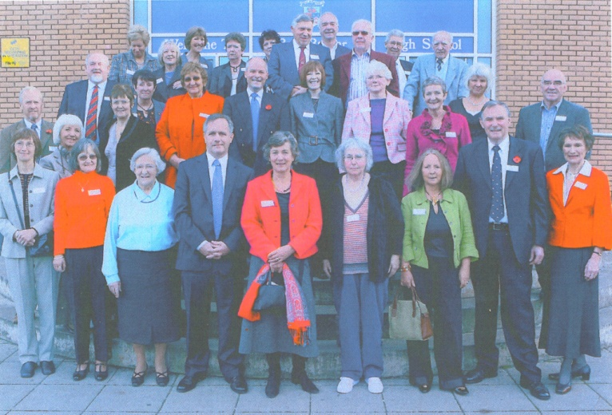
The pupils of the year were very slow to set the wheels in motion to find and contact their former pupils and it seemed that very few people kept in touch after leaving school. Inspite of this, 28 of the year, along with a few partners, attended a very enjoyable and nostalgic get-together, having travelled from all corners of the UK. The day began with a reception in the Staff Room of the 'new' building when the 'Head Girl', Liz Gordon, welcomed everyone including two ex-teachers, Muriel Dymock and Kenneth Nicoll, the new Rector, Philip Black, and some members of the FPA. Mr Black then welcomed the group to the school and said that he was very much in favour of FP Associations and that the Former Pupils were the best ambassadors for the school. This was followed by a photograph being taken on the front steps of the school and the cutting of a celebration cake emblazoned with the school crest.
A very attractive and tasty buffet lunch was enjoyed by all in the Café Bar, which was beautifully set up. There wasn't anywhere like that 50 years ago, though there was a tuck shop at the new school. Everyone was having such a good time chatting they didn't notice the desserts, and the catering staff had to serve these - or were the ex-pupils just too shy!
After the meal the group returned to the Staff Room for coffee, cake and lots more chat, and the opportunity to look at their class photos, school magazines, articles written or drawn by classmates and a few profiles sent in by some who were unable to attend the day. Mr Black kindly took those who wished on a tour of the school.
This was a great opportunity to meet up again after 40+ years and hopefully old friendships were rekindled. Safe to say, it was a very happy and enjoyable occasion, with a few commenting that the event wasn't quite long enough.

A 1948 Reunion
From Ron King (1948) comes a report of a Reunion (held in 2008) of an obviously hearty and flourishing group of ‘more than Golden’ Oldies!
Donald MacKenzie, Colin Crichton, Duncan Stirling and Ronnie King converged on Edinburgh's Scotch Mist Bistro at Peter's Cellars from the East, West, North and even further North of Scotland to celebrate our achieving three score years and ten. Billed as the CDDR Grand Day Out, the organisation was in Donald's capable hands. Suitable Certificates of Attendance and Antiquity as well as an especially baked and decorated cake marked the occasion. Reminiscences of Bell Baxter in the early fifties awakened dormant memories of good times and led to a long loquacious lunch! Absent friends were remembered and duly toasted.
In particular, we all miss Harry Sime who was a popular member of our schooldays group. As Flying Officer Sime, Harry died in July 1965 when his RAF Canberra suffered engines failure and crashed in Holland. The villagers where the plane came down commissioned a plaque as tribute to the skill and courage of the air-crew who stayed with the stricken aircraft and thus avoided a school in its path. There were no civilian casualties. Ours was a truly Grand Day Out. There are plans for another Colin Donald Duncan Ron celebration in 2013 - our 75th year.

Reunion Year of 1958
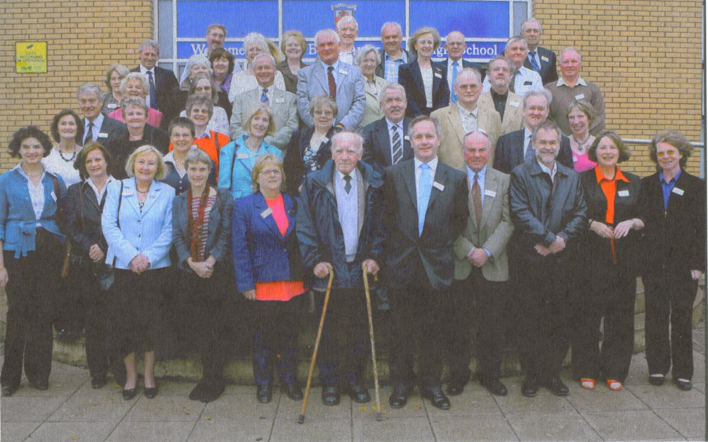
On an exceedingly ‘dreich’ day in October 2008 over 40 ex-pupils, some with partners, a sprinkling of the FPA committee, the current Rector, Mr. Black, and, (we were happy to see, since they were older than we were!) Miss Dymock, Mr Nicoll, Mrs Oliphant and Mr Docherty, gathered at the resplendently improved BBHS main building to exchange memories and wallow in nostalgia.
‘Google’ is a wonderful tool for such events, and classmates were discovered in all points of the UK, Italy, Bermuda, Barcelona, France and even New Zealand. Sadly not all could come, but emails were displayed from absentees.
Braving the weather the attendees followed the photographer outside for a commemorative photo, and possibly it was the weather which led to the ‘snappiest’ snapshot ever taken by a professional! That's my excuse anyway.
The organisation had started much earlier in the year, with four of the year group trying to find former classmates. Sandy Davis and Jenny Waddington provided essential and far- reaching advice to help the process along. The successful format of previous years was adopted whereby the BBHS catering staff provided a welcome drink and a splendid buffet lunch in the school conference room. The excited conversations started in the staffroom continued unabated over lunch, over coffee and, in some cases, later in a local hostelry.
After a welcome speech from Jennifer Wilson and encouragement from Derek Barrie to join the FPA, Mr Black invited any who wished to tour the new parts of the school, which proved to be the source of much envy, especially from erstwhile scientists.
Catching up on 40+ years of life stories went on enthusiastically till the ringing of the bell reminded all that the 'jannie’ had a home to go to.
Judging from the smiles, the chat, the informal exchange of contact details and subsequent letters and emails, the reunion was enjoyed by all who attended and already some further meetings have been arranged.

1945 Class Year - 63 Year Reunion
On Wednesday 8th October 2008 on a gorgeous sunny autumn day a Reunion Lunch was held in the Fairways Restaurant at the Elmwood Golf Course near Springfield to the West of Cupar. Of the 24 present 21 were former pupils, two were relatives, while Muriel Dymock, Editor of the FP Newsletter, was our guest. From 11 o'clock people assembled over tea or coffee and drinks from the bar. The reminiscing and catching up on personal news and news of others not able to be present proceeded at furious pace. The excellent quality three course meal at 1 o'clock was greatly enjoyed followed by reports on some of those not present and discussion of plans for the future - indeed whether at this stage there should be any further gatherings. Before the close it was agreed unanimously that there should definitely be a comparable event, if possible in the same venue, to celebrate 65 years in 2010.
Greetings and good wishes were received from classmates elsewhere including as far afield as Canada including a most delightful photograph of John and Joyce West (Ashcroft, British Columbia) - sent to convey their regret at not being present. During the photograph's inspection a remark overheard was: ‘Goodness, doesn't John now look so much like his Dad’, a much respected and favourite Technical Teacher at Bell Baxter during our time. Joyce, of course, prior to her marriage was Joyce Pitkeathly from Newburgh. The group was naturally saddened to hear of medical problems and close bereavements.
Special mention was made of Sandy Adamson's well-being whose interest in the lives of former pupils continues unabated.
Though numbers are dropping, from 34 of whom 25 were FPs at the 2005 Reunion, there are still 100 on the database being maintained by Sheila Scott, who was responsible for the reunion arrangements. Thirty-nine had sent apologies, which indicates continuing interest. However, this left 40 (40%) of former pupils who did not respond at all. We wondered what reason they may have for their silence. If you are still interested, do get in touch with Sheila at 6 Kildinny Yards, Kingsbarns, St Andrews KYI6 8TD.
Of course the reunion also gave FP Association members the opportunity to encourage those not members to join the Association and enjoy its benefits. For those of you with access to a personal computer, you may be interested in contacting the School's website: www.bbhs-online.co.uk which has an FP Association section to click.
Post Reunion opinion has clearly indicated that there is a strong desire to accept that our 65th Reunion in 2010 would be the last main gathering of Class Year 1945, after which those who wish to continue meeting in smaller groups would do so by making their own arrangements.

REUNIONS - 1959
50 Years or half a century - is an incredible number of years whichever way you look at it BUT on the 29th August 2009, it seemed like yesterday as the year of 1959 turned up to celebrate their 50 year reunion.
How did it all start? - well as you know as one enters into the latter stages of life one's memory is somewhat sketchy so I don't really remember how it all began. However early in the year Brian Samson, Liz Sutherland (Toulalan) and I got together in Edinburgh to set the wheels in motion. This of course was prompted by Muriel Dymock, without whom no reunion would ever take place. I also contacted Jennifer Wilson from last year's reunion group who gave us some pointers for starting up. Muriel had also presented me with a list of our year group names - all 400 +!
What a fascinating afternoon we had reminiscing over the names on that list - where were they, what were they doing and would they come to a reunion? An action plan was drawn up and so were dates for follow-up meetings. Fortunately with modern technology we had the assistance of Friends Reunited and e-mail - although this perhaps was a step too far for some of our age group! All of which got us quite excited as we started to track down the 1959 year group.
It was surprising how many of that year still lived locally, but unfortunately for some reason or another did not want to or could not attend.
We decided to go down the route of ‘Stardom’ - we contacted ‘our’ celebrities Artie Trezise and Rab Noakes - this was followed up with a photo shoot with Artie, which we hoped would stir up some local interest. Unfortunately through work committments neither was able to attend the reunion.
Numbers were low but we decided to go ahead, and again guided by Muriel Dynock, who said ‘you are better with 20 who want to be there than more who do not want to be’.
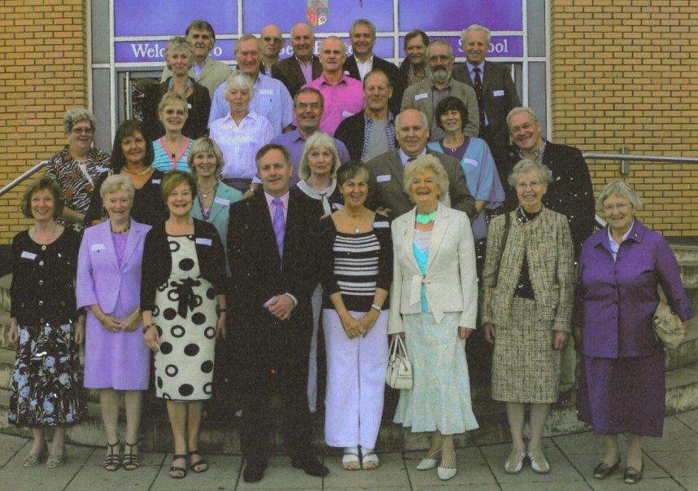
This proved to be the case when we eventually met up as a group of 29 on the 29th August 2009. They came from near and far - Germany, London, Renfrew, Aberfeldy and Cupar! We had name tags ready but it was soon apparent that ‘old’ faces and voices were quickly recognized. It was also a great pleasure to welcome several teachers, Margaret Thomson, Kenny Nicol, Alice Oliphant and Muriel Dymock; also Phil Black the Rector of the present school and the two captains, and Joe Manson and Derek Barrie representing the FP Association.
After a noisy start, and welcome when I recalled some of the ‘highlights’ of our first days at Bell Baxter High School, it was time for the Group photo, later to appear in the local press, and then Kathleen Ballantyne - the Head Girl of our year - cut the celebration Cake. I had also prepared a ‘Memory Corner’ with old School books, Jotters, my school Blazer, and PE kit! plus the collection of photos which everyone brought along.
A very enjoyable buffet lunch was served and this gave the group a chance to catch up with class mates. The school captains then gave a guided tour of the ‘New’ school, where those from further afield were able to compare the new - new building, with the old Westport building where many of us had started out.
All too soon it was time for departure with lots of promises made to meet again, whether informally or formally, but there was a very happy conclusion to what was a very worthwhile reunion for the year of 1959.
Contributed by Gina Logan

Class of 1960
PUPILS who started their high school days in Cupar 50 years ago held a reunion at Bell Baxter on 27 August 2010.
The event was attended by former pupils from all parts of Scotland, including the Borders, Edinburgh and Thurso, as well as many resident locally.
Various photos and memorabilia were on display, with the 'class of 1960' also enjoying lunch and a tour of the school led by current rector Phil Black, head boy Caoi Ledingham and head girl Lorna Archer.
The 1960 intake was the first complete year to use the facilities of the then new Bell Baxter building.
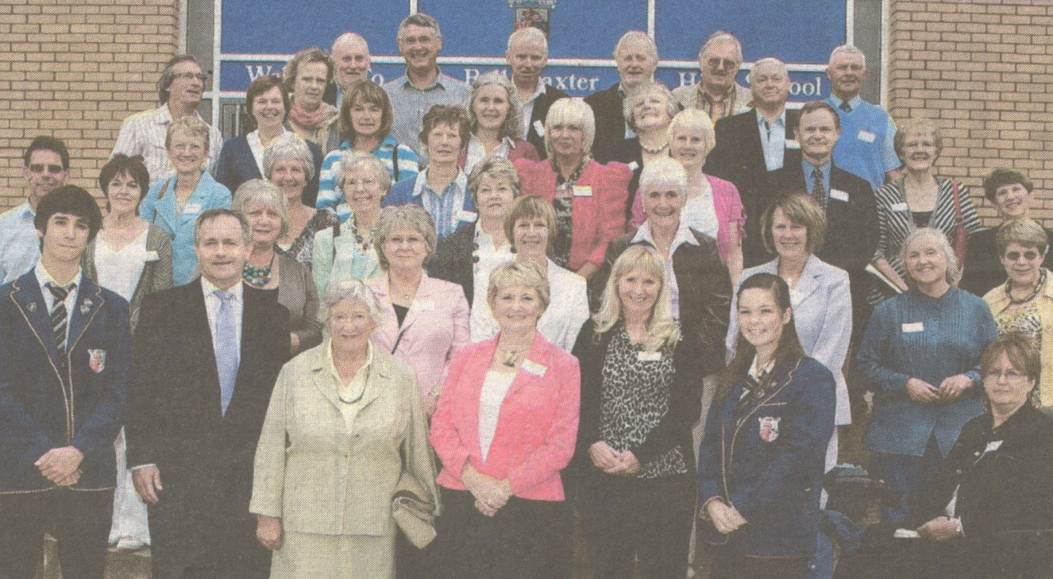
The photograph shows former pupils and former teachers (Miss Dymock, front, third from left and Miss Thomson directly behind her) with Mr Black (second from left, front) and the head boy and head girl. (Photo by Links Media).
YEAR of 1960 – Report for Newsletter
"Our rivers run to the ocean, and bear to every strand
Our fathers' vaunted craftsmanship, the pride of our native land.
So may we on the tide of time send ringing out to sea,
Bell Baxter, Bell Baxter, ad vitam sumus parati,
Hear thy sons and daughter praise thee."
Yes, Struthie not only remembered the words, but also the tune, and was so moved by the joie de vivre of the occasion that she lifted her voice in song - and left the rest of us suitably awe-struck. The occasion was, of course, the 50-year reunion for the ‘Class of 1960’ at Bell Baxter on Saturday 28th August 2010. We had a splendid turn-out of around forty people, and the school staff room resounded to cries of ‘Do you remember?’ and, ‘You haven't changed a bit!’
The welcome address was given by our old Head Girl, Helen Mercer (now Napier) in which she thanked the organising committee and welcomed two of our former teachers, Miss Dymock (French) and Miss Thomson (Maths) to the gathering. Thanks were also given to the Rector, Mr Philip Black, and the two School Captains who nobly gave up a precious Saturday to attend, and to give us a tour of the school after our splendid lunch.
Many of us had brought photographs, school magazines and other memorabilia - someone had even brought an old O-Level Maths paper! It all brought back many memories and gave rise to a lot of animated conversation.
I suppose people who were unhappy at school wouldn't attend a reunion event, but nevertheless it was striking how happy, fulfilled and moderately successful everyone there seemed to be. We may not have realised it at the time, but with hindsight we all have reason to be grateful to our school, and in particular for the fact that we were the first to move into the new Carslogie Road building from the tired old one down in Westport. It seemed most spacious and modern to us then, although now of course it has been dwarfed and surrounded by the extensions and expansions necessitated by the need to have a single-site school. Our Rector at the time, Dr J E Dunlop (‘Jed’), was inordinately proud of the new school and was wont to remind us at every assembly that we were ‘La crème de la crème’. Dr Dunlop and his Deputy, Miss Livingstone, made great efforts to ensure we were always smartly and demurely turned out and a credit to the school at all times.
Just to bring back a flavour of the ethos of Bell Baxter back then, I leave you with a quote from Helen's welcome address:
‘To finish, I thought you would enjoy a wonderful cutting that I found of the school prize-giving in 1965. Dr Dunlop had clearly spent hours thinking up the most obscure phrases. I will end by quoting a few of them: “When I look round and see the bad taste that seems to go hand in hand with prosperity, I am more than ever convinced that it is the prime duty of a schoolmaster to make his school an oasis of refinement in a desert of vulgarity.” We were urged not to join “the hordes of pseudo-intellectual queeries” (how language has changed since then) “who regard soap and water as outmoded and reactionary and look as if they had slept in their trousers and stolen their jacket from a tattie-bogle.” “When you go out into the world don't have people staring at you and pointing an outraged finger in your direction and asking in incredulous tones, 'Who is that Cuparian, vulgarian, hairy yin?'”
Ah, those were the days!

Class of 1945 - Final Reunion
The 1945 yeargroup was the first to initiate a class reunion on the occasion of the Centenary of Bell Baxter in 1989. The ‘45ers have since held a reunion every five years until 2004, and the 2009 one was advanced a year. Currently the oldest year group to hold a reunion, their last took place on 7th October 2010.
On a glorious autumn day a gathering of 23, including 17 former pupils, met for morning coffee and lunch at the Fairways Restaurant, Elmwood Golf Course, Stratheden, Cupar. Guest of honour was Miss Muriel Dymock, President of the Bell Baxter Former Pupils’ Association. Nineteen former pupils would have been present but, regrettably, two had to withdraw at the last minute for health reasons. Of the 90+ FPs on the address list the percentage of those who attended was approximately 18%, while 34% replied to indicate they were unable to attend. Many of those unable to be present sent their apologies, greetings and some included personal news and even photographs. News and photographs from three former class mates living in Canada was a delightful surprise. Our grateful thanks are conveyed to all who contributed to producing this treasure trove of news which brought such pleasure to the readers.
Our reunion chairman ~ Alasdair Morton ~ welcomed those present and also referred to those who were absent as well as reading a roll of honour of those deceased since our previous reunion in 2008, namely Helen (Robertson) Beveridge, Manson Riddell - October 2008, Martin Pirie - January 2009, James Coutts - August 2009 and a favourite teacher to many ~ Mr Alex Adamson (known by most as Sandy Ad). On a lighter note Alasdair mentioned an extract from the prize giving list of 6th July 1951, the last to be attended by members of Class Year 1945, that 'Dawson' was awarded the Colonel Lindsay Cup as winners of the House Championship that year and the two captains of the year were John McKendrick and Margot Fettes, both of whom were present at the reunion. ‘Can any other vintage year emulate that?’ he asked.
After taking a group photograph in the sun ~ the photographer being the son of a class member present ~ the group enjoyed a leisurely lunch with coffee which took over two hours to complete, such was the enjoyment of the company and the exchange of news and reminiscences of years gone by; certainly the decibel level was high. There was exhilaration in recalling pleasurable experiences, exchanging news of memorable events and incidents from work and leisure, of families and other contacts from over the years and the day proved all too short before farewells had to be made with a sentimental nostalgia in that this was the last such occasion and partings might be final. However, people were encouraged to continue to meet up with others in perhaps smaller groups in their immediate geographical area. It was also announced that a 1945er had this year (in January 2010) received an MBE from Her Majesty the Queen, for 50 years fund raising for the RNLI. 'Congratulations' Brownie (Melville) Wright, we wished you could have been with us, as we would have loved toasting your honour.
The considerable correspondence and planning details that this event entailed were undertaken successfully by Sheila Scott, and all present expressed their appreciation of her efforts for this and for two previous reunions (2005 & 2008). While not intending to continue keeping the database as an up to date record, some details may remain pertinent for a few years. Others wishing to get in touch with a classmate from the past can contact Sheila, who would be pleased to assist, where possible, with any queries with finding an address or other detail.
Contact Sheila at ~ 6 Kildinny Yards, Kingsbarns, St Andrews. KYI6 8TD.
Tel No: 01334 880 489 Email: sbrscott@talktalk.net

CLASS OF '61 GOLDEN REUNION
A long tradition of Golden Reunions continued at Bell Baxter last weekend (27th August 2011) with the Class of 61 gathering to celebrate 50 years from their arrival at the school. Organisers were delighted by a splendid turnout of 46 former pupils, who were joined by three of their teachers for a memorable day of fellowship and memories.
The school played host to the lunchtime event, which, after some initial querulous looks, assisted by name badges, soon resulted in a hubbub of conversations and laughter as school comrades, many of whom had not met since leaving school, began animated conversations on the events of their schooldays.
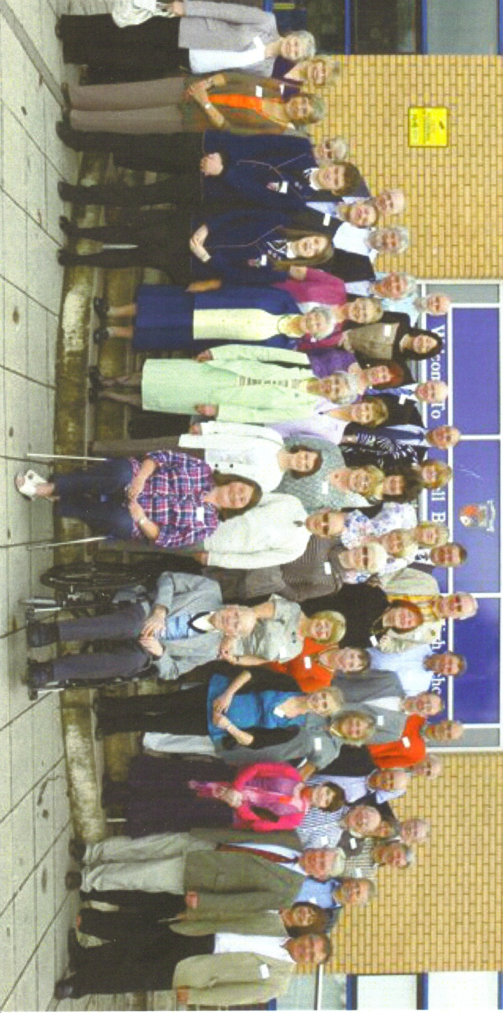
After a group photograph as souvenir of the day, the company were welcomed on behalf of the organising committee by Sandy Green, who reminded them of some of the momentous events of 1961, including the inauguration of President Kennedy, the start of the Vietnam War and the building of the Berlin Wall, and notable births, including Barack Obama and George Clooney. Sandy pointed out that the assembled company included such diversity as an ex-SAS Sergeant, a Commonwealth Games boxing silver medallist and the current Honorary Professional to The Royal and Ancient Golf Club of St Andrews. Some brief anecdotes on teachers of the time resulted in much merriment.
An impressive buffet lunch followed, provided by the school catering staff, giving the opportunity for much further reminiscing. Many of the FPs had brought photographs, school magazines and other memorabilia, providing great amusement and bringing back many memories of "the best years of our lives".
The FPs were delighted to welcome three former teachers: Muriel Dymock, who is President of the FP Association, and maths teachers Ken Nicol and Margaret Thomson, the former of whom is wheelchair bound and was particularly appreciative of the efforts to get him there. At the opposite end of the age range, the current School Girls Captain, Hannah Burgess and Boys Vice Captain, Ross Strachan, also attended and gave a most polished and informative tour of the school following lunch. The Class of 61 was only the second year to go up to what was then known as the New Bell Baxter, which itself is now barely recognisable due to the additions and extensions which have taken place in recent years. The school's superb gym and sports facilities, the library and research resources and state of the art science labs drew particularly favourable comments.
The afternoon drew to a close with tea and a special cake marking the occasion, emblazoned with the school badge and inscribed "Bell Baxter Reunion :Class of 61".
A vote of thanks to the organisers was proposed by Elizabeth Wallace, the Girls Captain of the year, and the company departed determined that there should be a further similar get together five years hence.

YEAR OF '56
This year group had decided, following the very successful 50th anniversary reunion, to keep the group together and organise a 55th get-together. As guests at the previous one, Ken Nicoll and Muriel Dymock may have wondered just how well attended another would be after only 5 years. They need not have worried, for it was another very happy, noisy group which foregathered in the School Staff room. There were around 50 people present this time - just over half the number present at the first one but just as enthusiastic. The interest was such that there is a move to have another one in 3 years. Surely for such a lively group, suggestions of age cannot be creeping in? Ah, well! - none of us knows and it is better to be safe than sorry to have missed the opportunity.
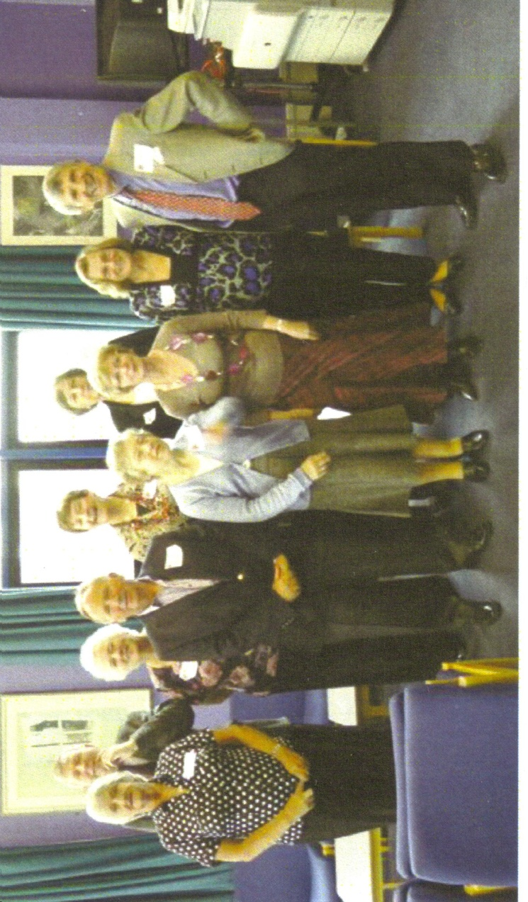
A smart ‘c’ class – 55 years on
Jim Thomson gave a lively and amusing welcome and Aileen Paterson entertained us with reminiscences of which she has retained a great store.
In the evening many of the group met up at the Byre Bistro - now "Kingarroch at the Byre" - where the hosts are 2 young FPs - making a very pleasant end to a very happy day.

